Registering Your Child in the Seymour Community School District

Step 1: Registration Portal
Initial Registration  Go to www.seymour.k12.wi.us, click on Online Registration then on Register Now and fill in the form with your information  If you are applying for Open Enrollment, please call the District Office before completing this form.  If you would like to apply for Intra School District Transfer, please call the District Office before completing this form. | Students who are NEW to the district or are returning after transferring out of the district.
1st Email: Confirmation
You will receive an email confirming that you have completed the information in the Registration Portal.

***Please note*** This email simply acknowledges that your application has been received.
2nd Email: After Approval
After you have completed the information within the Registration Portal, your information will be reviewed, and if eligible, you will be approved. Once approved, you will receive a 2nd email with information on how to create an account in the PowerSchool Parent Portal.

***Please note*** Your student access ID and student password to link your student to your parent account will be at the bottom of this email message.
Step 2: Online Registration within PowerSchool
Step 2a: Create a Parent Account  Use the Student Access ID and Student Password that were emailed to you to create your PowerSchool Parent SSO Account  - Go to https://ps.seymour.k12.wi.us/public  - Click Create New User  - Enter your information, including a desired parent username and parent password.  - Enter the Student Name, Access ID & Access Password (from the email).  ***Please note*** If you already have a PowerSchool Parent SSO Account, then you can login using your username and password. See instructions below. | 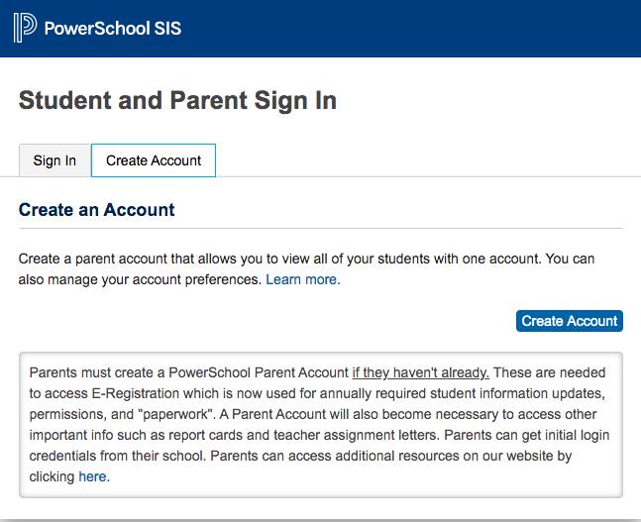  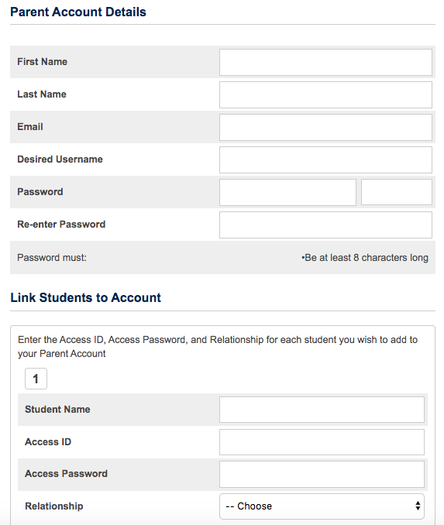
Already Have a Parent SSO Account?  ***Only complete this step if you already have a Parent PowerSchool Account, and you need to add a child to that account.***  - Log into your PowerSchool Parent Account using your username and password.  - Click on Account Preferences in the left menu.  - To add a new student to your parent account, click on Students and then Add.  - Enter the information provided to you in the email to add the student to your account. Click OK.  - You will now see all of the students associated with your account across the top menu in PowerSchool. | 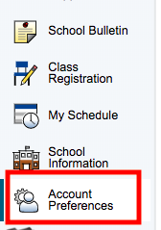  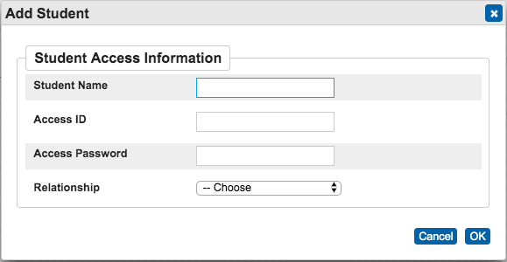
Step 2b: Complete Online Registration

Once signed into the PowerSchool Parent Portal, click on Forms in the left menu. Then at the top of the page click on the ENROLLMENT tab. This is where you will find all of the registration forms that need to be completed for online registration of your child(ren).
Click on FORM A1 to begin the PowerSchool online registration process.  The status of the form will appear to the left of each form:  - Empty (Blue)  - Pending (Yellow)  - Approved (Green)  The status bar to the right will show your progress towards completing each step in the online registration process.  ***A green status bar means all forms within that section have been completed.*** | 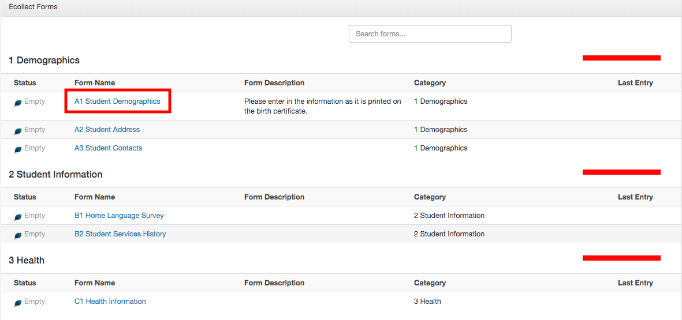
Ecollect Preferences are optional. If you would like to receive notifications that could be sent regarding Ecollect status, you can fill in your information.  *Please note: This is not part of Connect 5, our Emergency Notification System. The information you enter in the Demographics section will be used for Connect 5. | 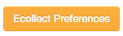  *Optional
Questions with a red asterisk are required.  A red flag by a question means that a new response has been submitted. You can hover over the flag to view the old and new responses. | 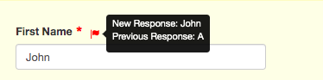
After completing the form, click on the Submit button at the bottom of the screen.
The following documents cannot be uploaded. These documents must be brought into the school office to complete registration:  - Birth Certificate | 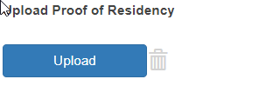
Click Browse to search for the document on your computer.  Click on Upload | 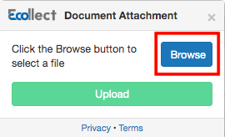
You will see the uploaded document(s) under Document Name. | 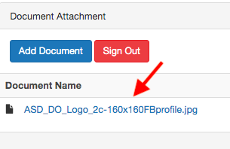
All of the Ecollect Forms should be completed within PowerSchool to complete your online registration. You can check the status of completion with the red/green status bar. | - A1 - Student Demographics  - A2 - Birth Verification  - A3 - Student Address  - A4 - Student Contacts  - B1 - Pervious Enrollment  - B2 - Home Language Survey  - B3 - Student Services History  - B4 - Permissions/Agreements  - B5 - Technology  - C1 - Health Authorizations  - C2 - Health Information  - E1 - Acknowledgement of Completion
Congratulations! You have completed the online registration. Please bring the following documents to the Seymour School District Office.
- Child’s Birth Certificate (4K, 5K, or if enrolling from out of state)
- Proof of Residency (if not already uploaded)
- Immunization Record
- Physical Exam for 4K & Kindergarten students

